# INFORMATION ON RETIREMENT PENSION



**Social Protection Reform Project**

**中国-欧盟社会保护改革项目**

# INFORMATION ON RETIREMENT PENSION

The citizens can come to our offices to get informed on the date and the amount of their retirement pension.

They can come with a previous appointment on the day chosen by them and through the “previous appointment” programme that appears on our web page and which I show you.

They also can come without appointment, as they prefer. Anyhow, **we are committed to a waiting time of no longer than 12’ until they are helped.**

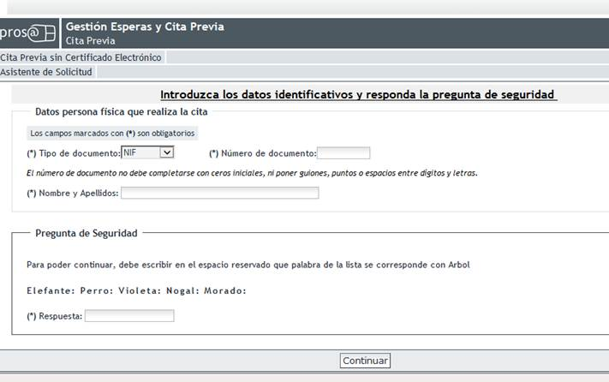

Once they are in our office, if they have a previous appointment, only by introducing their DNI (national identification number) or NIE (foreigners’ identification number) in our electronic readers, they obtain a printed appointment and go to the reception room. If it I not so, the officer at the entrance will give them a printed appointment, according to the time possibilities of the CAISS, and, from this moment the procedure is the same as in the previous case.

The DNI or NIE is the only document we require from them, both for the appointment and to continue with the attention thereafter, as we must ascertain the identity of the citizen.

Once in the waiting room and always in a time of less than 12’, the citizen will automatically be called by an officer to his or her table, numbered by our intelligent waiting system, SIGE. For this purpose, the number which the citizen has appears in the two screens we have, strategically placed in the CAISS, and, the number of the officer’s table who will help him or her appears right after.

Once the officer has checked the will of the citizen to be informed, he or she will discharge from our Intranet and from one of the three helping tools, globally called **i-consulto**and, specifically from “CaissGestiona”, the simple application for information, which the citizen fills in and signs (to comply with the Act on Protection of Data).

An image of the procedure is shown.

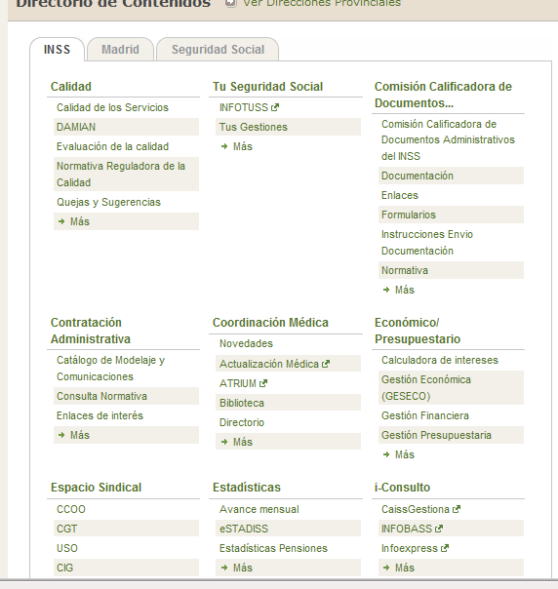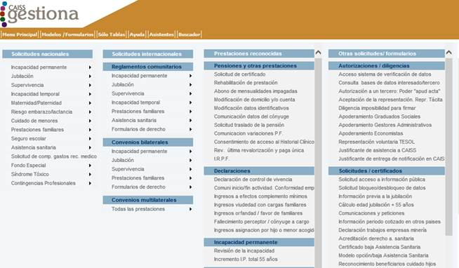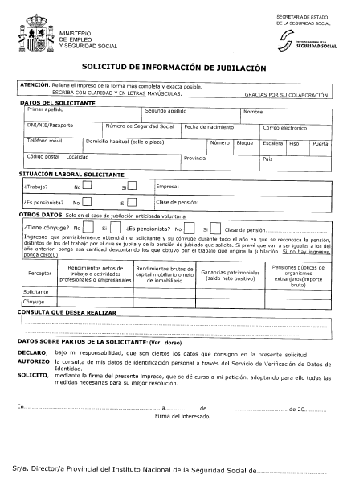

Once the citizen has filled in the application, we will introduce his or her Identity Card. Our computer application “ALFA” will pick up his or her personal data, which are afterwards reviewed by the officer, who adds other data, like his or her marital status and the date when he or she wishes to retire.

The image is shown.

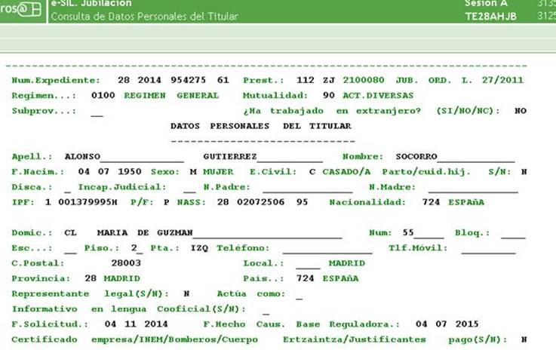

Once the personal data have been reviewed, the computer application itself picks up the data on the contribution bases, needed to solve the procedure, and carries out its account in days.

In the example shown, they are 14716 days.

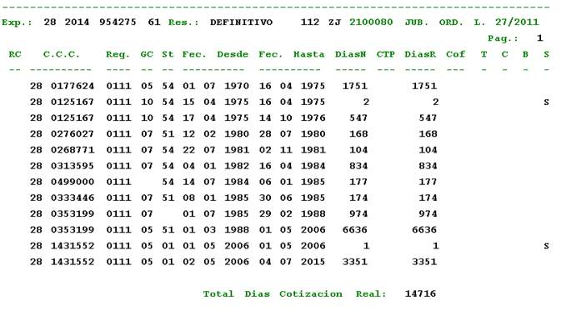

Once all the needed data have been collected, the system calculates the amount.

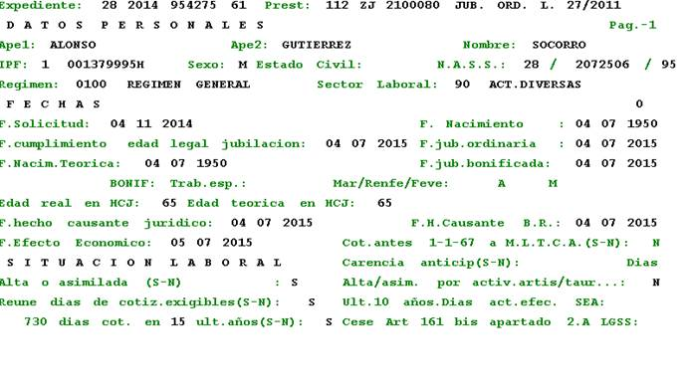

At the end, we give the citizen an **approximate resolution with the calculation of his or her future retirement pension.**

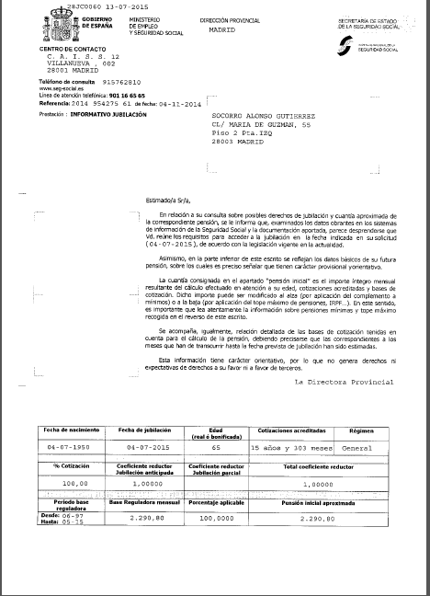

Furthermore, and if he or she wishes to do so, he or she may also carry out a self-calculation from his or her home, using the link in our web page: [**www.seg-social.es**](http://www.seg-social.es)

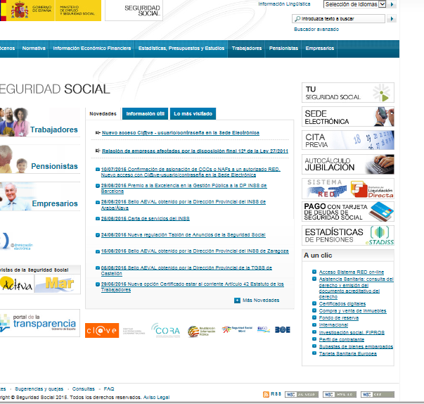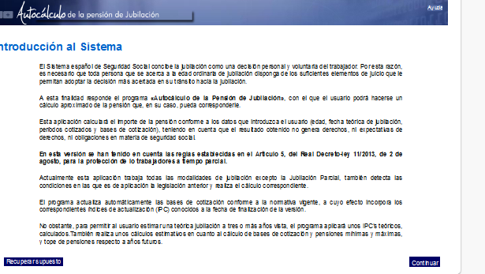

Madrid, September 2015