**MATERNITY ALLOWANCE**



**Social Protection Reform Project**

**中国-欧盟社会保护改革项目**

MATERNITY ALLOWANCE

The citizens can come to our offices to apply for the maternity allowance for child birth.

They can come with a previous appointment on the date chosen by them through the “previous appointment” programme that appears in our web page and that I show you:

They can also come without appointment, as they prefer. Anyhow, **we are committed not to let them wait for longer than 12’ until they are helped.**

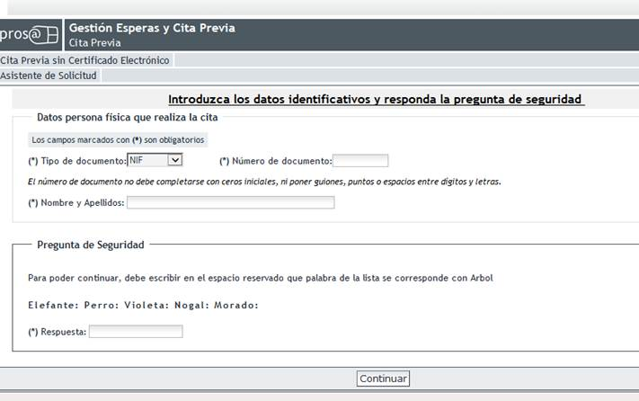

Once in our office, if they have an appointment, only by introducing their DNI (national identification document) or NIE (foreigners’ identification number) in our electronic readers, they obtain their printed appointment and go to the reception room. If this is not the case, the officer at the entrance will give them a printed appointment according to the possibilities of time of the CAISS and, from this moment, the procedure is the same as in the previous case.

The DNI or NIE is the only document we require from them, both for the appointment and for the attention thereafter, as we must ascertain the identity of the citizen.

Once in the waiting room, and always before 12’ have elapsed, the citizen will automatically be called by an officer to his or her table numbered by our intelligent waiting system, SIGE. For this purpose, the number the citizen has received appears in the two screens we have, which are strategically placed in the CAISS, followed by the number of the table where the officer will help her.

Once the officer has proven the will of the citizen to be informed, he or she will discharge from our Intranet and from one of the helping tools, globally called **i-consulto**, and specifically from “CaissGestiona”, the simple application for maternity allowance, which the citizen fills in and signs.

The image of the procedure is shown:

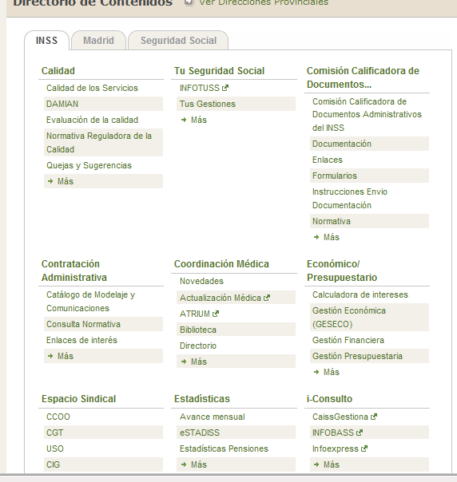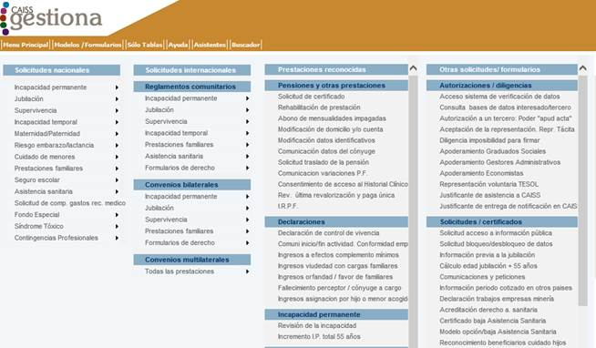

As essential documentation annexed to the application the citizen only has to submit her original **DNI**, as the **family booklet,** where the birth is accredited, and the **enterprise certificate,** showing the dates of start and end of the benefit and other details of the labour situation of the applicant is an information that can be obtained from the different data bases of the INSS).

We verify immediately that the applicant meets the requirements to accede to the benefit (to be registered with Social Security at the time of the causing fact, minimum exclusion period, thenon responsibility of the enterprise and the contributions of the enterprise, to calculate the regulatory base) and, thereafter, the entry of the application is registered.

Once the documentation and the requirements have been proven, we go to the **procedure phase:**

1. **Capture of personal data and of the benefit:** Once the Social Security number of the applicant has been introduced in the computer application, all the necessary personal and labour data, sought in different data bases (also those of the General Fund of Social Security and of the Civil Registry) appear. Once the data have been verified, we introduce the date of commencement of the rest period and the other details that she had included in the application: Income tax (IRPF, possible admission in hospital of the new born, bank account number, civil status…

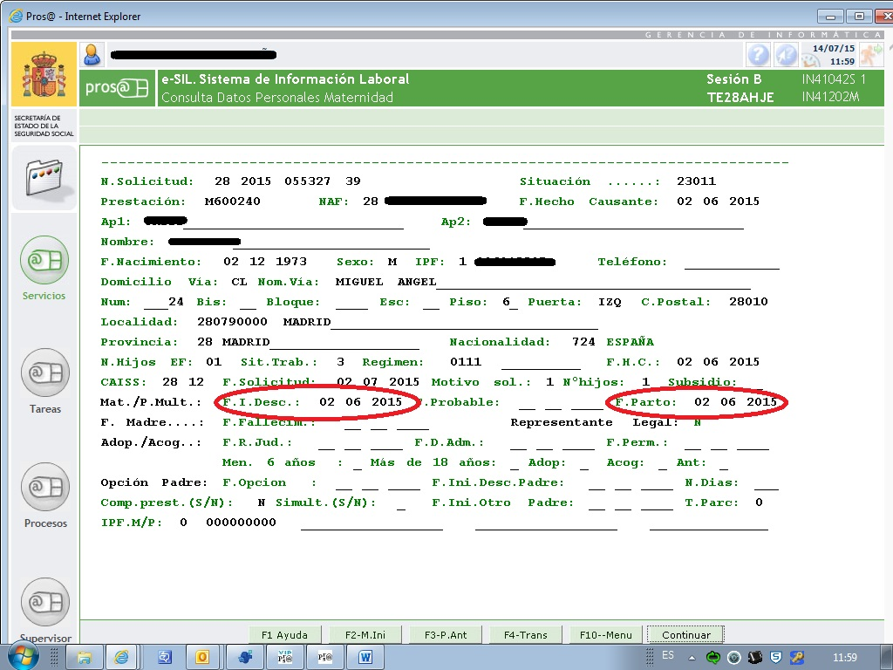

1. The application also includes the data that the enterprise has previously registered. Also these data are verified **in order to obtain the regulatory base** for which we are going to pay the allowance.

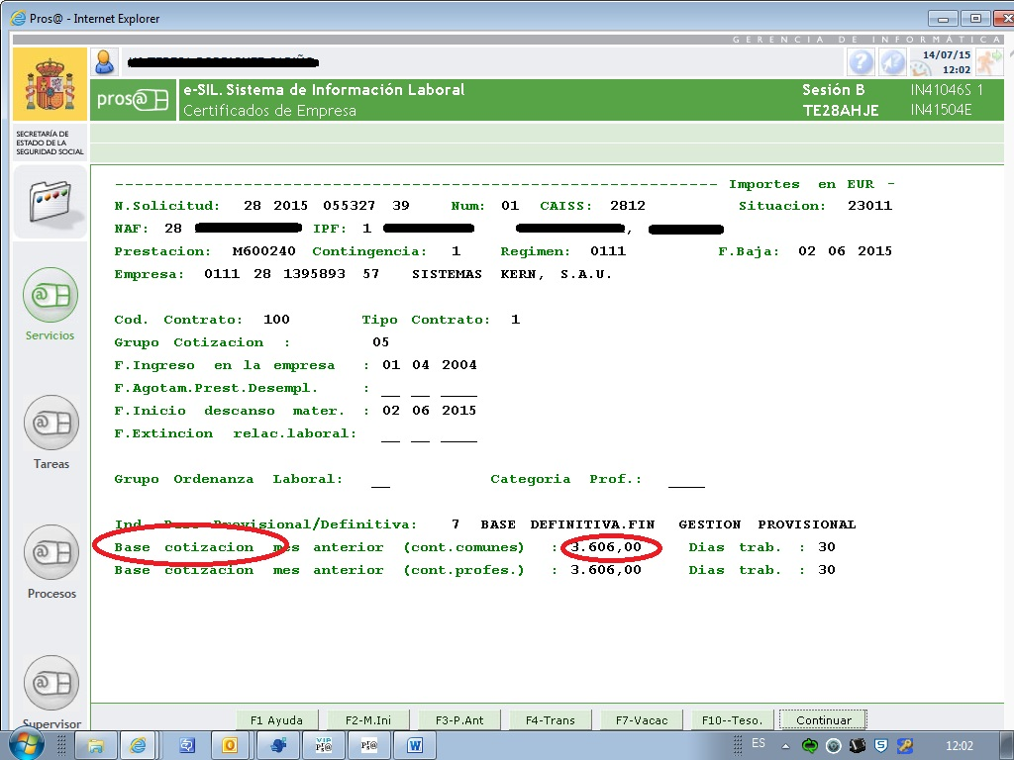

1. The **bar code** of the procedure is extracted in order to scan all documents.

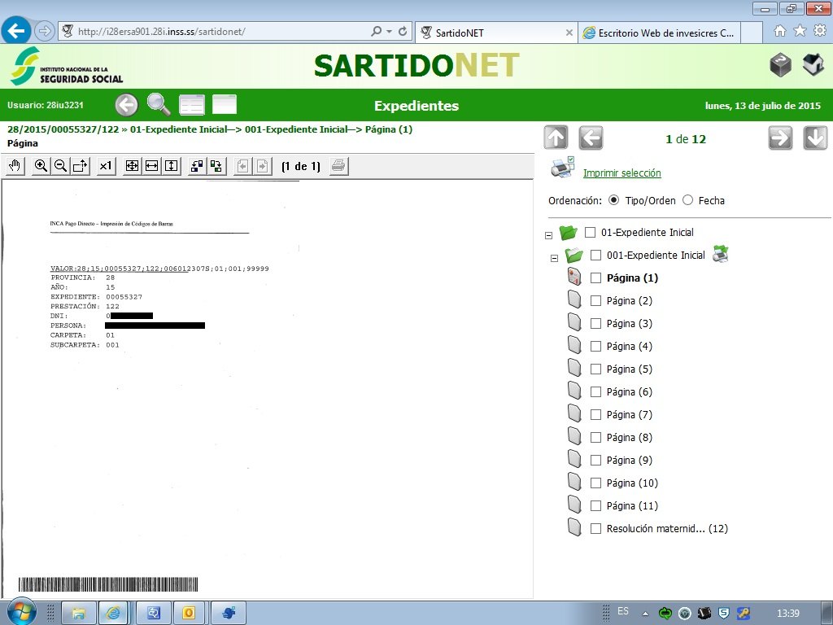

1. **The right of the applicant is then examined and the procedure is rated**: the possible discounts are applied, we indicate a possible responsibility of the enterprise, we verify the exclusion period and we approve the procedure.

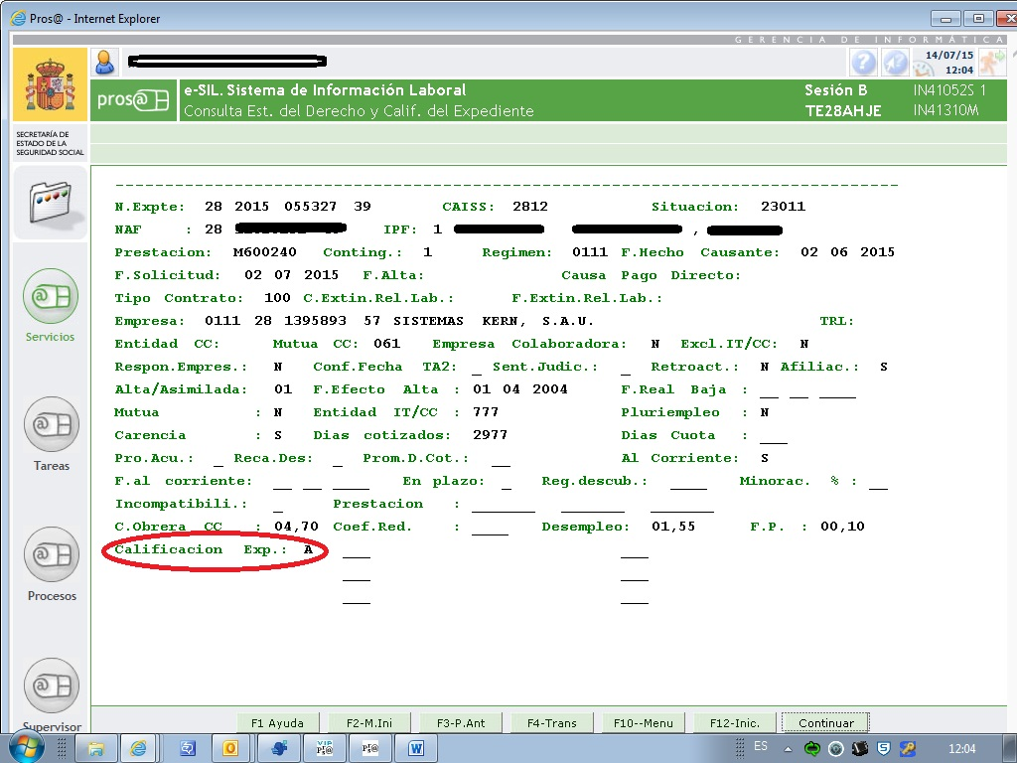

1. **Calculation of the allowance:** the application generates the daily regulatory base and the acknowledged payment period with all the data previously introduced. We prove the calculation and the resolution of the benefit is generated.

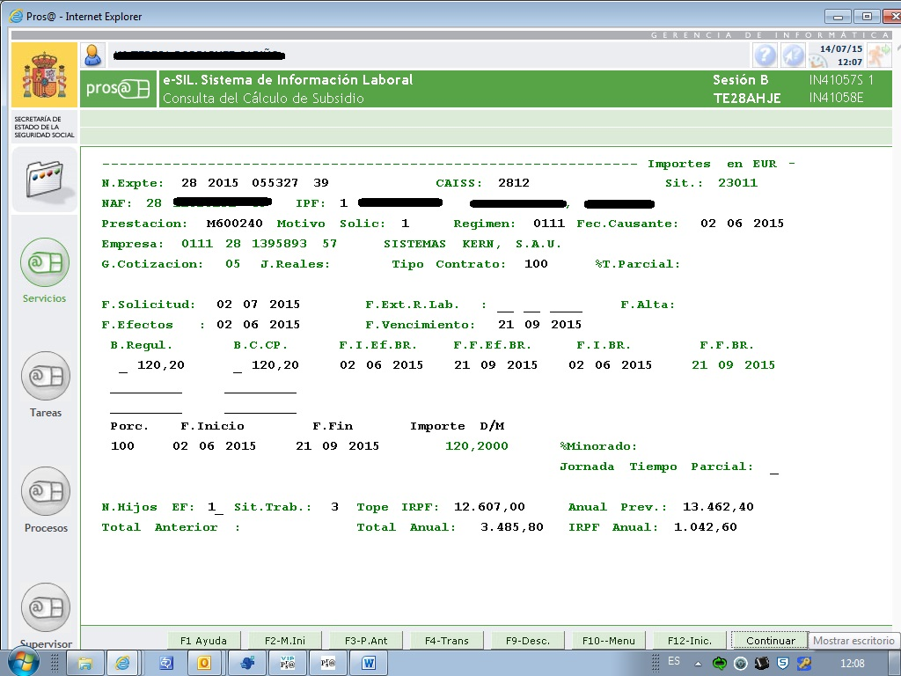

1. **The order for the first payment of the benefit is issued**(the rest of the payments are made with the monthly automatic wages.
2. **The citizen receives the resolution of the benefit per registered mail and the payments in her account.**