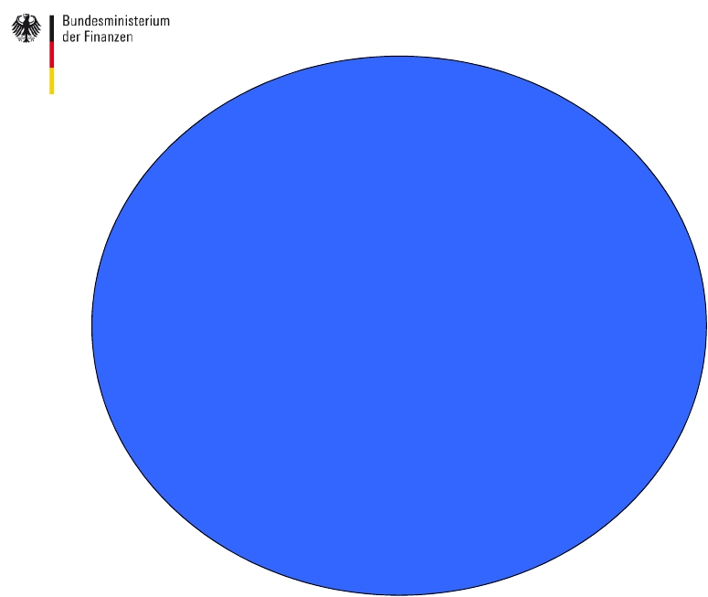DR. WOLFGANG MERZ

Presentation on Best Practices in EU.
Sustainability of pension systems.
养老金体系可持续性欧洲最佳范例
Madrid
June 22, 2016

Structure of my intervention

我的发言结构

• You already had a training session 5: „Pension systems reforms in the EU.Best practices. Discussion.“ 已经参加培训5‘养老金体系改革欧洲最佳范例讨论’

• There are overlaps but I will add the following elements: 内容上有一定重合，重点介绍以下方面：

• A) integration of Member States: EU, but also Eurozone. 欧盟成员国、欧元区的整合

• B) change of method of policy coordination: from 政策协调方式改变：从最佳范例到基准水平
OMC/best practices to benchmarking

• C) Own analytical basis: the ageing report. 自主分析基础：老龄化报告

• D) Not so much examples for pension reforms, but 主要介绍养老金改革原则
principles.

• E) View of Finance Ministers: huge pension block with no direct influence.
财政部门视角：缺乏直接影响
Federal Ministry of Finance
2

Berlin

Building blocks of my intervention基本模块

• Key words: Best practices (more binding methods in EU-deepening). EU (also Eurozone).
Sustainability (Ageing Report). Pension systems (Principles for a pension policy).
关键词：最佳范例，欧盟（欧元区），可持续性（老龄化报告）养老金体系
• First block: Method of policy coordination and EU/Eurozone dimension (state of the art).
第一模块：政策协调方式和欧盟、欧元区维度
• Second block: Sustainability - theory and analysis: Ageing Report.
第二模块：可持续性-理论和分析：老龄化报告
• Third Block: Policy Options for pension reforms of the Ageing Report, principles of the Eurogroup.
第三模块：养老金改革政策选择，欧盟基本原则
• Summary: Referring to the last EG principle: political obstacles (reforms are unpopular, you can loose power, also hesitance to make the method more binding).
总结：欧盟基本原则：政治性障碍（改革不受欢迎，容易失去影响力，手段不利推进凝聚力）

3

First Block: Method of policy coordination and EU/Eurozone (state of the art)

首先块：政策协调，欧盟/欧元区（技术发展水平）的方法

• Pension systems can be addressed in an EU or in a Eurozone context, where you need more ambition.
养老金体系可以在欧盟、甚至欧元区层面进行统筹
• This makes a difference, in particular with regard to the level of policy coordination.
统筹层次不同，对政策协调水平要求不同
• At EU-level the weakest form is the Open Method of Coordination (OMC), created during the Lisbon
Strategy. This is a very light exchange of view about policy options.
在欧盟层面上，约束最小的协调方式是“开放式协调”（OMC），里斯本战略期间形成，在政策选择方面的观点交流比较基础
• Stronger is the instrument „best practices“, where you have a certain anchor, which one can follow.
协调程度较高的方式是‘最佳范例’，提供其他国家进行效仿。
• But even this is not enough for a Eurozone context. The target should be higher, e.g.
By using a „benchmarking concept“.
在欧元区层面，‘最佳范例’还远远不够。通过‘基准’概念把目标设高。

2nd Block: Sustainability of pensions: the2015 Aging Report as basic underpinning
第二块：养老金可持续性：为基本支柱2015年老龄化报告
• The respective joint Member States (EPC)/European Commission Ageing Report is under
certain aspects now a „bible“ (15 years of experience).
欧盟委员会老龄化报告已有15年实施历史

• It tries to approach the issue of „sustainability“ (S1/S2-indicator).
主要关注‘可持续性’问题

• It has the aim to cover different public expenditures which will be affected by ageing, not
only pensions.
针对与老龄化相关的各项公共支出而不仅局限于养老金

• It benefits from similar methodological approaches which will be regularily reviewed.
相同的方法手段，周期性审核

• You have a good comparison among all member states. Report forms solid analytical basis
to assess reform progress.
呈现成员国之间的比较。报告为评估改革进程提供坚实的分析基础。

5

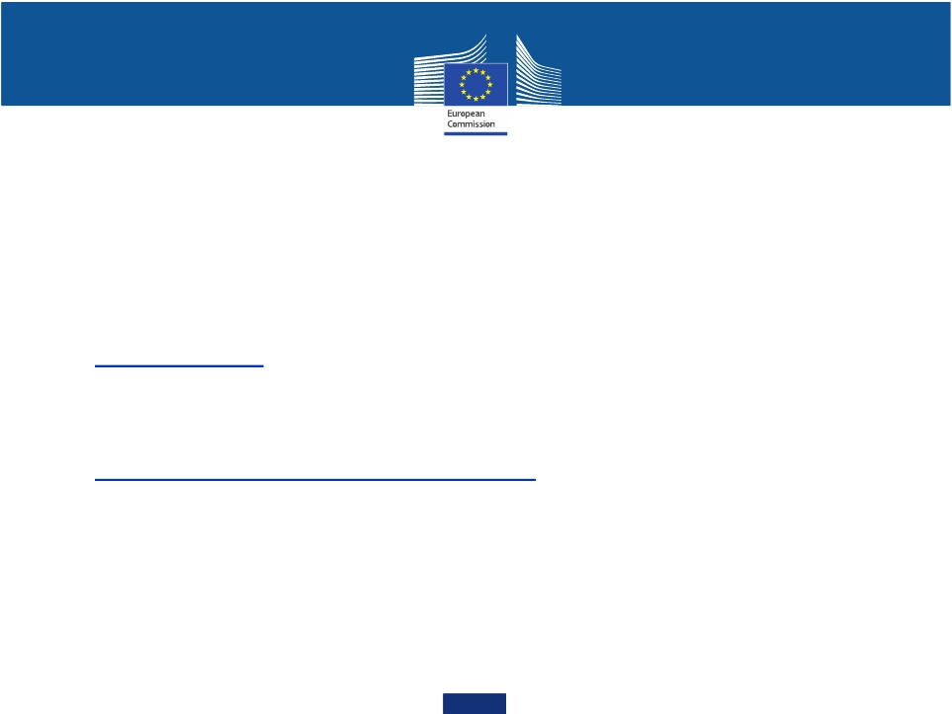
2015年老龄化报告
2015 Ageing Report (1)

Joint Commission (ECFIN)-EPC (AWG) long-term projection exercise – 2015 Ageing Report
2015年老龄化报告

• Fifth update of the joint EPC-Commission long-termprojections (previous 2001, 2006, 2009 and 2012).
欧盟议会-欧盟委员会长期计划第五次修订（前四次:2001, 2006, 2009, 2012)

• Mandate of the ECOFIN Council (May 2012) ECOFIN理事会
"The Council INVITES the Economic Policy Committee to update, on the basis of new population projections to be provided by Eurostat, its analysis of the economic and budgetary implications of ageing by the autumn of 2015’
“理事会邀请经济政策委员会，根据欧洲统计局提供人口形势变化分析，于2015年秋季前提供
最新老龄化对经济、预算形势的影响分析报告。”

6

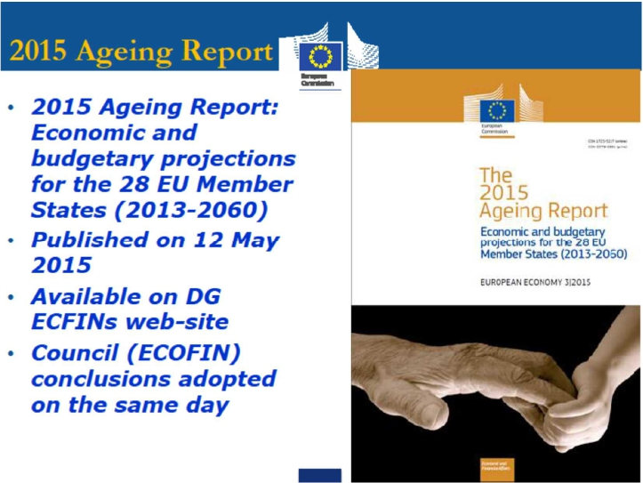 Aging Report (2) 年老龄化报告

2015年老龄化报告：对28个成员国经济和预算预测（2013年至2060年）
发表于2015年5月12日
可在DG ECFIN网站
理事会（ECOFIN）的结论所采用的同一天

7
The details: the 2015 Ageing Report projection exercise细节：2015年老龄化报告预测的工
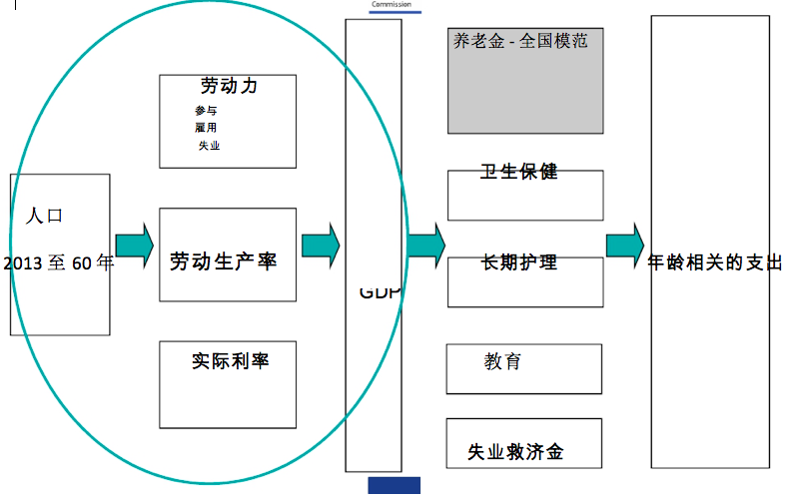
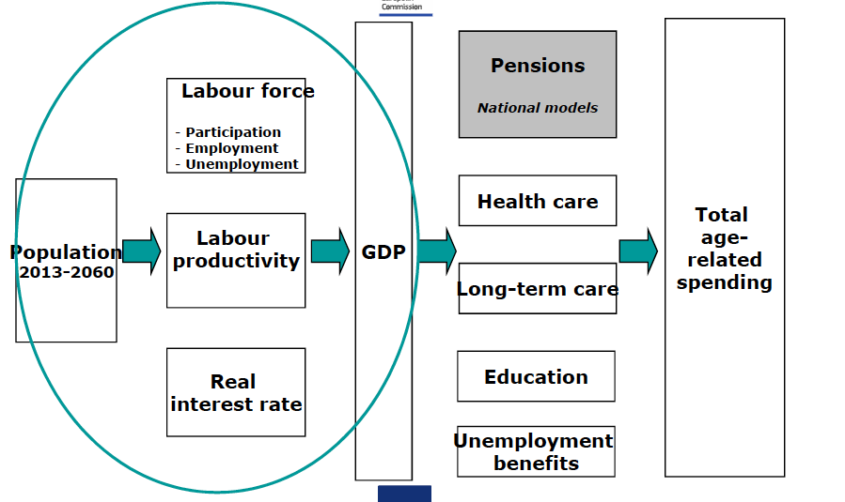

人口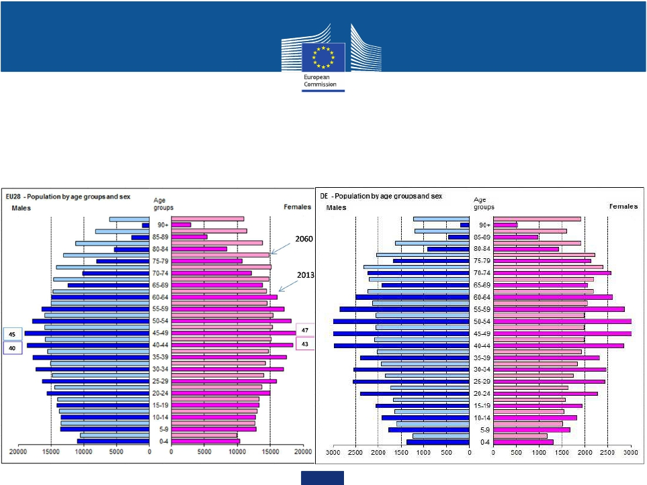Demography

Size and composition of the population人口数量及构成

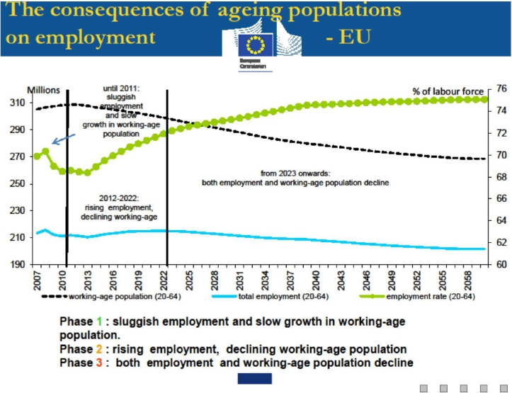就业人口老龄化的后果

1.低迷的就业和劳动年龄人口增长缓慢
2.失业率上升和下降，劳动年龄人口
3.就业和劳动年龄人口下降 10

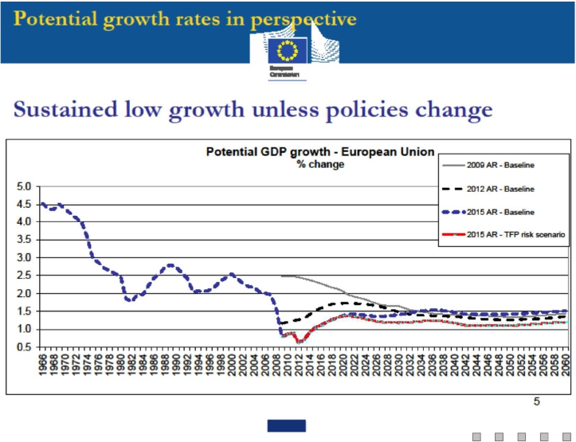增长率预测

持续的低增长，
除非政策改变

11

Federal Ministry of Fin

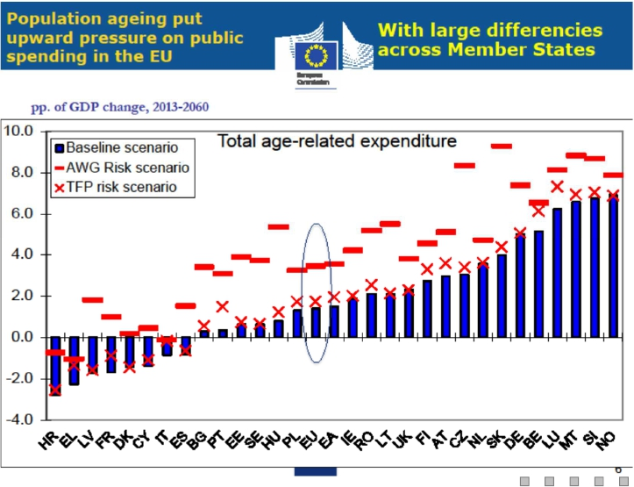公共支出压力上升 -与成员国之间的差异大

12

预计支出增长规模降低

Federal Ministry of Finance 13

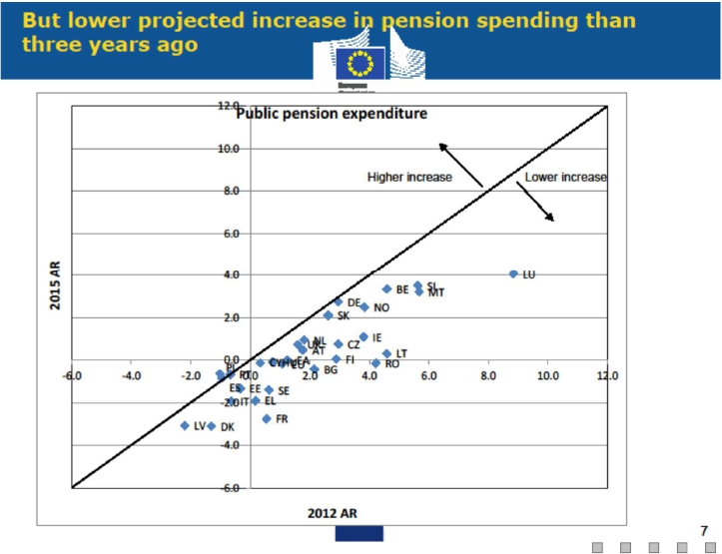

Third Block: Policy Options for pension reforms of the Ageing Report and principles of the EG
第三块：对欧元集团的老龄化报告的养老金改革和原则的政策选择

• Policy options of the Ageing Report: 老龄化报告政策选择

• A) Automatic balancing mechanisms to reinforce resilience.
自动平衡机制以加强制度弹性

• B) Sustainability factor (benefit link to life expectancy).
可持续性因素 （待遇和寿命关联）

• C) Retirement age linked to life expectancy.
退休年龄和寿命关联

• D) Flanking polices to ensure sustainability while maintaining social adequacy.
全面政策以保证可持续性、社会充分性

• E) Supporting sustainability through labour market and growth-enhancing measures.
通过劳动力市场、刺激增长措施支持可持续性

Federal Ministry of Finance
14

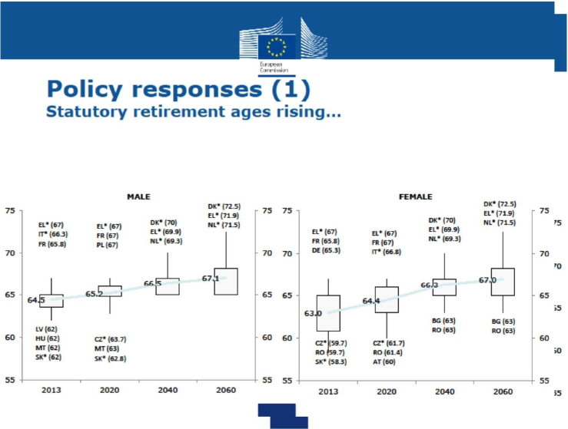

15

政策回应 (1) 法定退休年龄提高

政策回应(2) 退休的持续时间上升太多，但没有那么多。

（剩余预期寿命法定退休年龄）
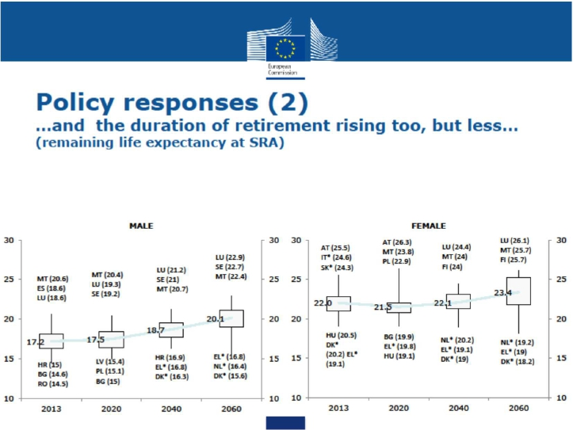

16

政策回应(3)其结果是，更高的有效退休年龄

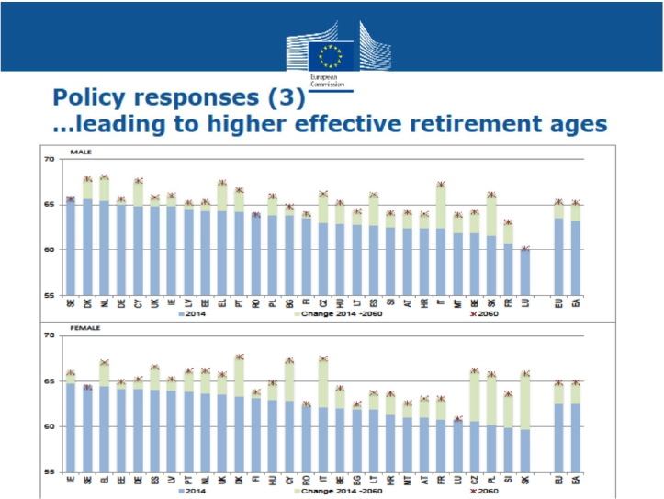

17

What “old” is - ‘老龄’的定义
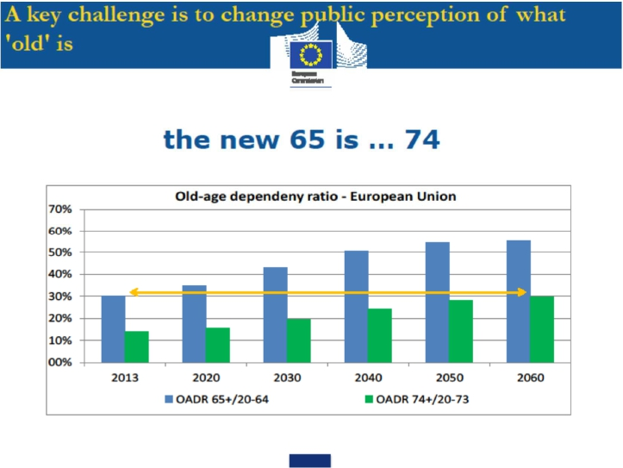新的65... 74 / 老年抚养比率

18

人口结构的未来变化的养老金政策越来越多地纳入。

1. 自动平衡机制 2. 可持续性因素（利益挂钩寿命）3. 退休年龄挂钩寿命 (芬兰，2015年11月)

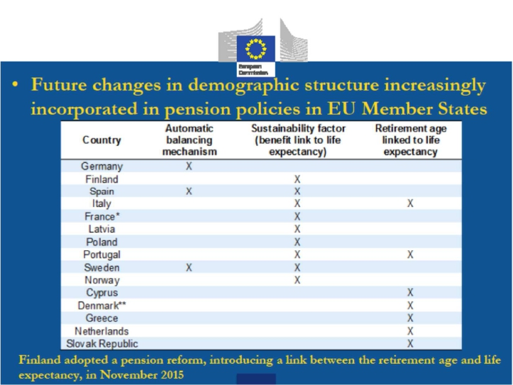

19
退休年龄与寿命关联

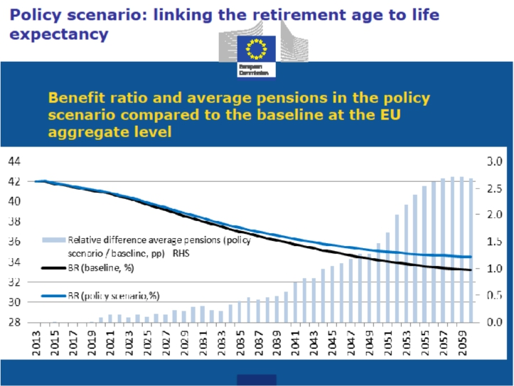20

与养老金改革进展情况：公共开支（其他城市2013至60年％GDP）
项目显示，2060年金的支出不会高于
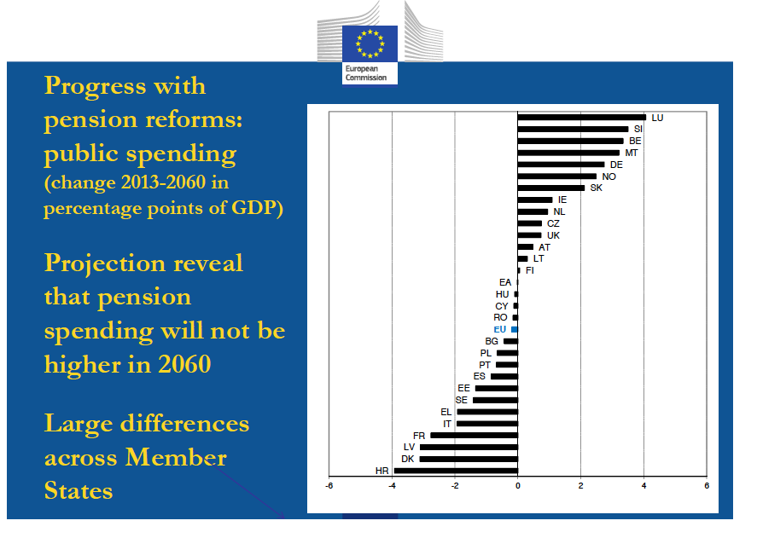
在成员国之间差异大

21

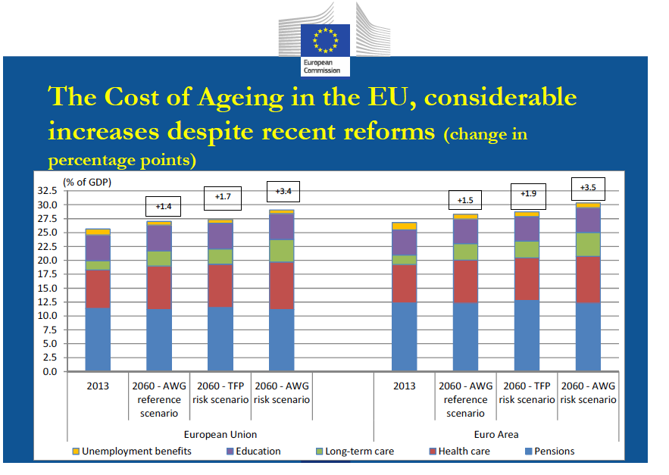
老龄化带来的开支增长显著 （百分比)）

失业福利 - 教育 - 长期护理 - 健康护理 - 家庭式
22

 |  | Public pension expenditure as % of GDP
 |  | 2013 | 2030 | 2060 | 2013-2060
AR 2009 | EU  EA | 10.2 11.4 12.5  11.2 12.6 13.8 |  |  | 2.3  2.6
AR 2012 | EU  EA | 11.2 11.9 12.9  12.1 13.0 14.1 |  |  | 1.6  2.0
AR 2015 | EU  EA | 11.3 11.6 11.2  12.3 12.9 12.3 |  |  | -0.2  0.0
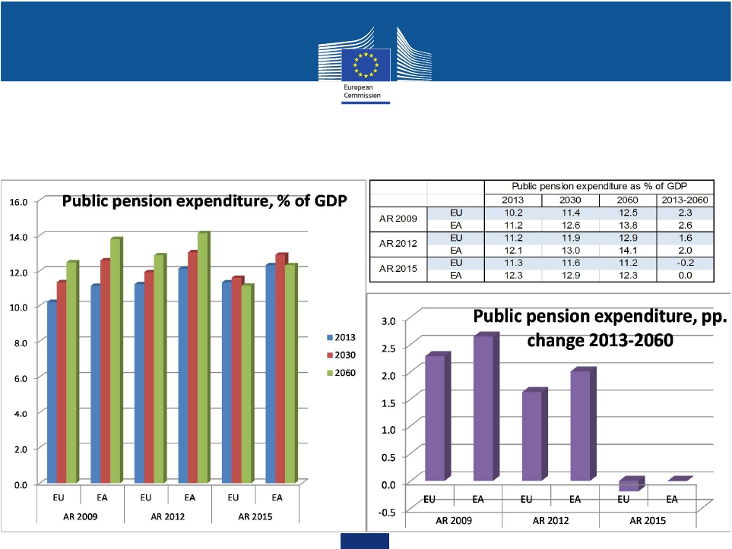

预计养老金开支Successive waves of pension spending projections

与欧盟养老金改革的总体进展，但是，定期检查仍然是必要的Overall progress with pension reforms in the EU, but, regular checks remain necessary…

公共养老金支出占GDP百分比

23

 | S0  Short-term fiscal sustainability challenge |  |  | S1  Medium-term fiscal  sustainability  challenge | S2  Long-term fiscal  sustainability  challenge | Overall risk  assessment
 | S0 | Fiscal subindex | Financial-  competitiveness  subindex
BE | 0.11  0.26  0.09  0.21  0.00  0.12  0.30  0.20  0.16  0.20  0.19  0.28  0.12  0.13  0.14  0.16  0.17  0.08  0.20  0.30  0.27  0.16  0.20  0.23  0.13  0.38 | 0.20  0.17  0.11  0.00  0.00  0.00  0.36  0.28  0.18  0.30  0.28  0.10  0.00  0.00  0.08  0.00  0.10  0.10  0.10  0.26  0.00  0.35  0.11  0.10  0.10  0.34 | 0.07  0.29  0.08  0.29  0.01  0.17  0.28  0.16  0.14  0.16  0.15  0.35  0.17  0.18  0.17  0.23  0.20  0.08  0.25  0.32  0.39  0.08  0.23  0.29  0.14  0.40 | 4.7  -1.3  0.0  -2.6  -0.9  -2.9  5.1  1.5  3.4  5.1  2.5  -0.5  0.3  -3.2  -0.8  0.1  -1.0  1.6  -0.3  3.8  1.1  2.8  -1.0  3.4  -1.4  4.7 | 4.3  2.3  3.5  1.4  1.5  1.3  2.5  -0.3  0.0  -0.1  -2.1  1.4  3.2  5.0  1.1  4.6  3.3  2.8  2.7  0.4  3.9  6.5  3.2  5.0  2.3  4.2 | HIGH  MEDIUM  MEDIUM  LOW  LOW  LOW  HIGH  MEDIUM  HIGH  HIGH  MEDIUM  LOW  MEDIUM  MEDIUM  LOW  MEDIUM  MEDIUM  MEDIUM  MEDIUM  HIGH  MEDIUM  HIGH  MEDIUM  HIGH  MEDIUM  HIGH | BE
BG |  |  |  |  |  |  | BG
CZ |  |  |  |  |  |  | CZ
DK |  |  |  |  |  |  | DK
DE |  |  |  |  |  |  | DE
EE |  |  |  |  |  |  | EE
IE |  |  |  |  |  |  | IE
ES |  |  |  |  |  |  | ES
FR |  |  |  |  |  |  | FR
HR |  |  |  |  |  |  | HR
IT |  |  |  |  |  |  | IT
LV |  |  |  |  |  |  | LV
LT |  |  |  |  |  |  | LT
LU |  |  |  |  |  |  | LU
HU |  |  |  |  |  |  | HU
MT |  |  |  |  |  |  | MT
NL |  |  |  |  |  |  | NL
AT |  |  |  |  |  |  | AT
PL |  |  |  |  |  |  | PL
PT |  |  |  |  |  |  | PT
RO |  |  |  |  |  |  | RO
SI |  |  |  |  |  |  | SI
SK |  |  |  |  |  |  | SK
FI |  |  |  |  |  |  | FI
SE |  |  |  |  |  |  | SE
UK |  |  |  |  |  |  | UK
EU | : | : | : | 1.8  1.6 | 1.7  0.8 | : | EU
EA | : | : | : |  |  | : | EA

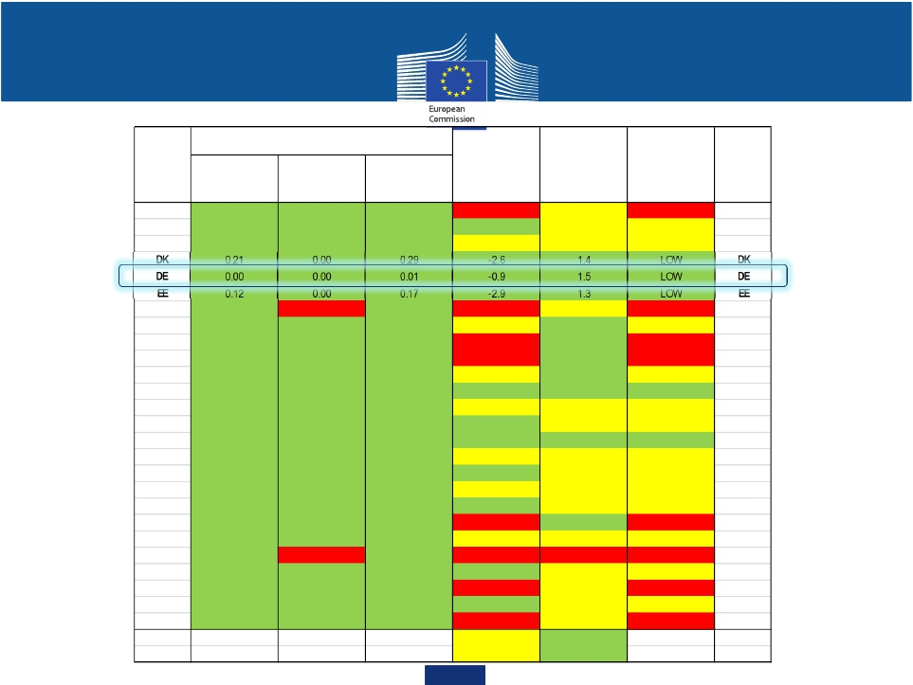
Fiscal sustainability - challenges across different dimensions财务可持续性：不同维度上的挑战24

Third Block: Policy Options for pension reforms of the Aging Report and principles of the EG
第三块：对欧元集团的老龄化报告的养老金改革和原则的政策选择

• Ongoing debate in the Eurozone on structural reforms in a broad sense and on issues which affect the public budget.
欧元区关于结构性改革、影响公共预算各项事务的持续讨论

• Method triggered via EMU-deepening.
通过‘深化经济和货币联盟’形成的具体手段方法

• Last EG (June 16th) postulated four principles:
近期欧元集团提出四大基本原则

25

Principles of Pension Reforms of the Eurogroup 欧元集团养老金改革原则

• 1) Safeguard against demographic and macroeconomic risks (f.e. via automatic balancing
mechanisms)
防止人口结构、宏观经济结构风险（如，通过自动平衡机制）

• 2) Flanking policies (reforms to extend working lives, boost retirement incomes, increase older
people‘s employability, etc.)
全面政策 （改革延长工龄、提高退休收入、提升老年人工作能力）

• 3) Broader reforms to strengthen growth and employment (adapt work places to changing
demographics, etc.)
全面改革，促进增长和就业 （调整工作环境已适应人口结构变化）

• 4) Anchoring political and societal support (develop common understanding, constructive
dialogue with stakeholders)
巩固政治、社会支持（加深认识，与利益相关方建设性对话）

26
Federal Ministry of Finance

Principles of Pension Reforms of the Eurogroup (2) 欧元集团养老金改革原则 (2)

• These principles should be regularly monitored.
监管原则的贯彻执行

• Member State and Commission are invited to develop appropriate benchmarks.
成员国和委员会参与制定合理‘基准’

• Report back to the Eurogroup in the first half of 2017.
2017年上半年向欧元集团汇报反馈

27

Summary 总结

• Sustainability of pension systems: a complex and political sensitive issue with an EU- and an Eurozone dimension.
养老金系统可持续性：一个复杂、政治敏感的话题，涉及欧盟、欧元区

• Theory and Analysis: Ageing Report (sustainability indicators; expenditure categories;
good comparison).
理论和分析：老龄化报告 （可持续性指标、支出类别、比较）

• Policy options: automatic; sustainability factor; retirement age; flanking policies; supporting
measures.
政策选择：自动、可持续性因子、退休年龄、全面政策、配套措施

• EG principles: most delicate number 4: hard to implement such reforms as pensions despite a very
expansive monetary stance. You can loose your political power.
欧元集团 原则：注意第4条: 养老金改革实施难度大不仅仅体现在财政资金方面。改革有松动政治权力的风险。

28

Thank you very much for your attention!

谢谢！

29

