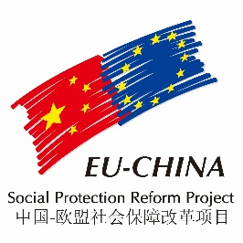
COMPONENT TWO – SUMMARY OF 2015-2016 ACTIVITIES

PANEL DISCUSSION MEETING IN BEIJING
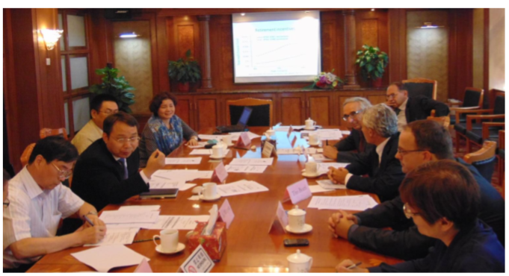
The first C2 Panel Dicsussion Meeting was held on 17th September 2015 in Beijing at the MoF. The meeting, chaired by Mr. Fu Jinling, Deputy Director General of the Social Security Department of MoF, provided an opportunity to share the Chinese experts’ assessment on the topics “The division on decision power and expenditure responsibilities on social security between central and local government” and “Nominal personal account reform in the basic pension insurance system”, with the European experts building on these results through their insightful comments and suggestions. A selection of European best practices deemed as particularly suitable for addressing the priority issues of the Chinese stakeholders were shared with the audience. Mr. Tito Boeri, president of INPS, made a keynote speech on the European Notional Defined Contribution models, in comparative perspective with the Chinese policy reform trend.

The second C2 panel discussion meeting covering the topics “Models and Methodologies for the Social and Economic Sustainability Analysis in Social Protection System” and “Social security Coverage on Informal Employment: Methodologies and Tools of Analysis and Management” was held on 16th December 2015 in Beijing. MoF and MoHRSS representatives attended the Panel. Chinese experts presented their respective findings, on which the European expert commented before proposing to the audience a selection of European best practices, in line with the priorities highlighted by the Chinese stakeholders.

Workshop on NDC Systems and Public Pension Reform
The workshop “NDC Systems and Public Pension Reform: Challenges, Prospects, and EU Experiences” was held on 15th December 2015 in Beijing, Renmin University, in cooperation with the Ministry of Finance. During the Workshop meeting the participants made an analysis and then discussed on the main issues concerning the public pension reform in China, while sharing EU best practices on NDC pension systems, redistribution issues and pension management tools used in EU Countries, such as Poland, Italy and Sweden.
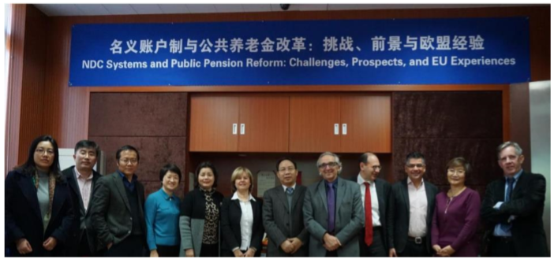

SOCIAL SECURITY PANEL
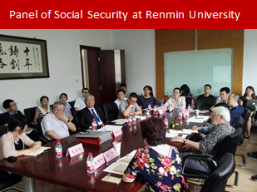
On 15th June 2016, Mr. Bruni participated as speaker at the Panel “Construction of the Governance Mechanism of Social Security During the Social Transformation”, organized by the Institute of Social Security Department of Renmin University. Prof. Dong Keyong and Prof. Li Zhen co-chaired the panel. Around 20 participants attended the activity; among these were prominent researchers, scholars and professors, such as Prof. Zheng Bingwen (CASS), Mr. Jin Weigang (MoHRSS), Mi Hong (Zhejiang University), etc. Prof. Bruni gave a presentation titled: “The aging challenge: measures and policies. The case of the EU”. The panel discussion was a great opportunity to exchange experiences and opinions among the participants.

WORKSHOP “The Sustainability of the Social Protection System in a Changing Working Environment”
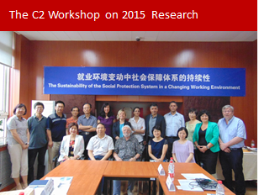
On 12th July 2016, the Component 2 of the EU-China Social Protection Reform Project, in collaboration with the Chinese Ministry of Finance, organized a Workshop at Renmin University, titled: “The Sustainability of the Social Protection System in a Changing Working Environment”, as part of the 2016 activity plan. Some 30 participants, including representatives from MoF, MoHRSS, scholars and professors from prominent research institutes, as well as the European Delegation, the project Resident Experts, and four EU short term Experts took part in the discussions.

Topics under review were: social security coverage on atypical employment: methodologies and tools of management, and models and methodologies for the social and economic sustainability analysis in social protection system. Mr. Fu Jinling, Director General of the Social Security Department of MoF, and Mr. Michele Bruni, Team Leader and EU Resident Expert of Component 2, jointly chaired the Workshop.

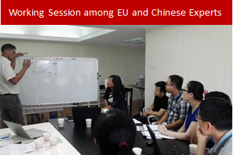
Following the Workshop, an in-depth working session led by Ms. Geng Shuyan (Actuarial Department, Social Insurance Administration Center, MoHRSS), involving 5 staff members of the Actuarial Department of MoHRSS and the EU experts, Mr. Carlo Mazzaferro (Bologna University) and Ms. Angela Legini (Actuary Staff, INPS), was organized by Component 2, in order to better acknowledge both the practices and current issues within the Actuarial Department of MoHRSS, introduce and explain the EU and Italian actuarial methodologies and processes used for the projections on social protection.

TRAINING COURSE IN ITALY- “European Practices for a Fair and Sustainable Social Security System. Governance, Long term Strategies and Financial Management”
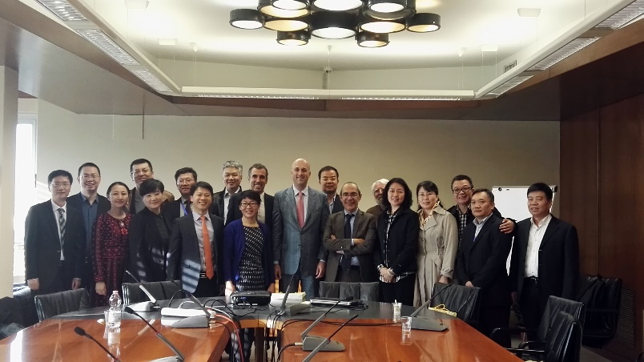
The training course “European Practices for a Fair and Sustainable Social Security System. Governance, Long term Strategies and Financial Management” was held from 16th to 30th October, 2016, in Italy (Rome and Florence). The course was attended by 15 officials from the Social Security department of the Chinese Ministry of Finance (3 from the central government and 12 from 12 provincial offices). The delegation was led by Mrs. Zu Guoying, Deputy Director-General of the Social Security department.

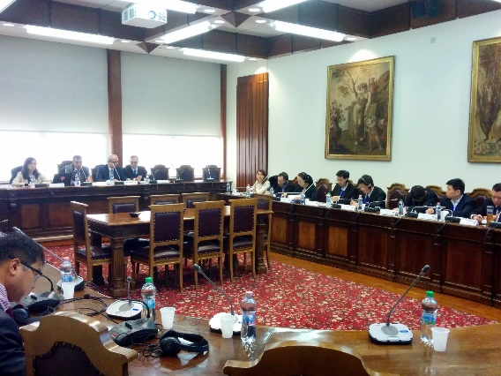
This training - a relevant activity of the 2016 program of the C2 EU-China Social Protection Reform Project - was jointly organized by the Italian Institute of Social Protection (INPS), acting both as Project Leader and Component coordinator; the Italian National School of Public Administration (SNA), a Consortium partner of the project; SISPI, Secretariat of the Component; and the Component Two team of the Beijing project office.

The first part of the training was devoted to a background analysis of different European social protection systems; the following to a presentation of INPS, its role and organization, with a focus on the Italian social protection system. The analysis of the impact of the demographic transition on the population of EU countries led to a discussion on the sustainability of the EU social protection systems and of the analogies with the Chinese situation. The problem of sustainability introduced: i) the presentation of the tools used by INPS and by the Ministry of Economy and Finance - in particular by the State General Accounting Department of the Ministry (RGS) - to forecast, monitor and evaluate the impact of alternative welfare policies; ii) the issue of contribution collection and the special challenges created by the increasing presence of atypical employment. The following training sessions dealt with the financial management of complementary pension funds, long term care, and means testing. Overall, during the training, around 30 specialists from Italy and other European Countries delivered presentations. Each training session also included time for discussion. The field visits allowed the participants to discuss and compare with their colleagues of Italian institutions work procedures, tools and technology so to increase specific skills. The delegation had the possibility to visit: INPS headquarters and Data Center in Rome as well as the Florence provincial headquarter; the Institute for the development of workers’ vocational training (ISFOL); the Ministry of Economy and Finance; the Bank of Italy, and the Pension Funds Security Commission (COVIP).

