WHO IS WHO – COMPONENT THREE
MAIN CHINESE PARTNER: The Ministry of Civil Affairs of the People’s Republic of China MoCA
C3 PROJECT LEADERS FOR MoCA:

PROJECT C3 COORDINATORS FOR MoCA:

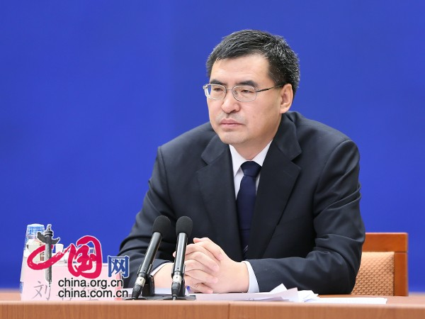
Mr. Liu Xitang, Director of Department of Social Assistance, MoCA

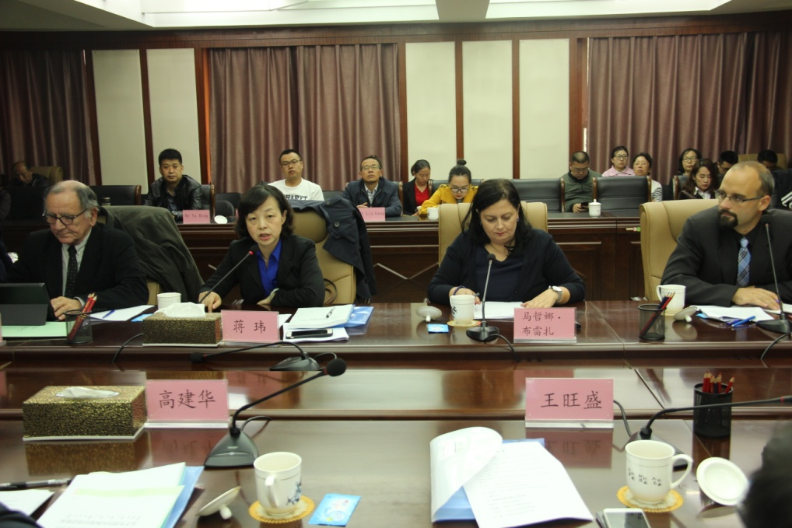
Ms Jiang Wei, Vice-Director of Department of Social Assistance, MoCA

Ms Zhang Lin, Director, Division of General Affairs, Department of Social Assistance, MoCA

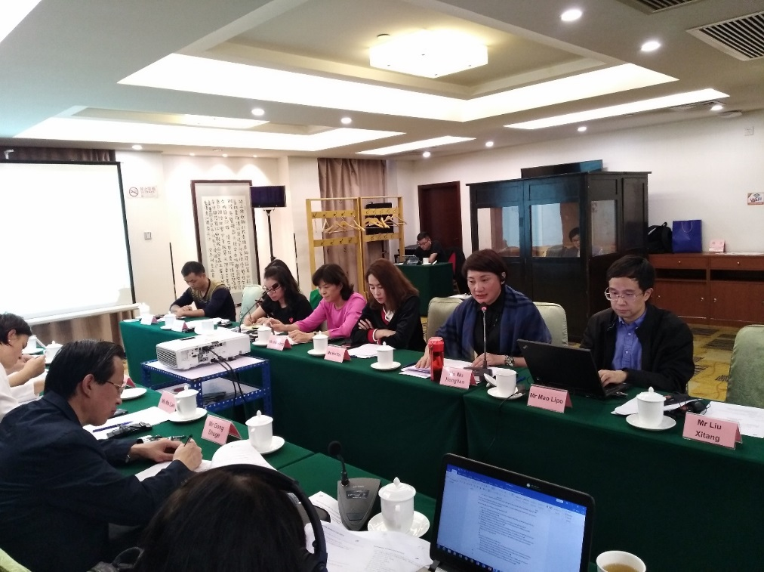
Mr Mao Lipo, Deputy Division Director of Administration, Department of Social Assistance, MoCA

Mr Chen Xunchui, Deputy Director, Center of Monitoring and Verification for Low Income Families, MoCA

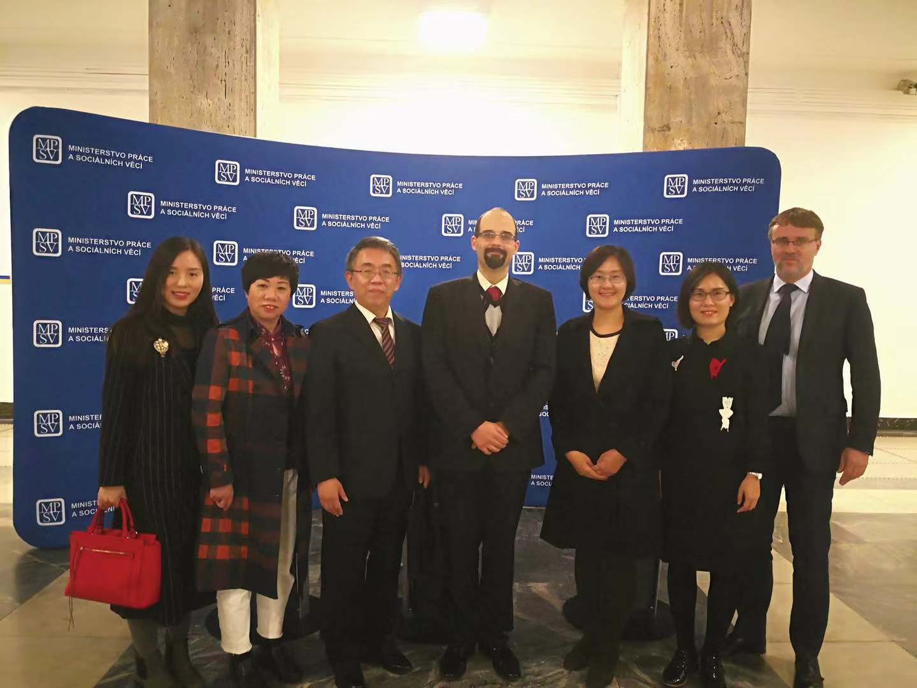
Mr. Li Weidong, Deputy Director, Center for Monitoring and Verification of Low-income Families, MoCA

Ms Xue Qiuji, Officer, Center of Monitoring and Verification for Low Income Families, MoCA

Mr. Wang Guan, officer, Center of Verification and Identification for Low-income Families, MoCA

C3 COMPONENT COORDINATOR: The Ministry of Family, Labour and Social Policy of Poland

Ms Agata Tomasiak,

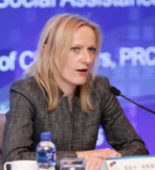
Ms Monika Szostak,

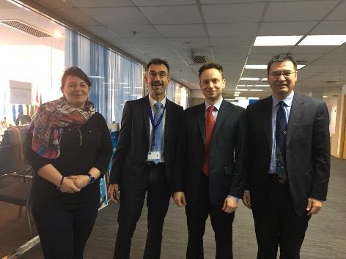
Mr. Marcin Grzegorz Pietruszka,

THE PROJECT TEAM IN BEIJING
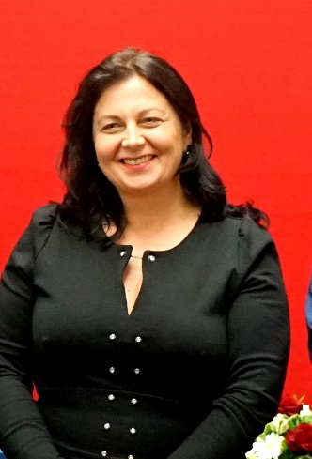
Resident expert Ms Marzena Breza

Component 3 Assistant – Ms. Iwona Rogacka-HU

