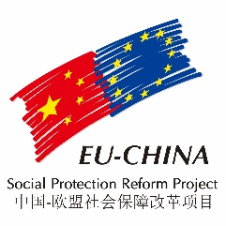
LIST OF PROJECT OFFICE MEMBERS

FUNCTION | NAME | DATES | NATIONALITY
Team leader  (and resident expert component 2) | Mr. Stefano Patriarca†  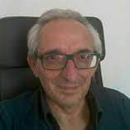 | 2015 | Italy
 | Mr. Michele Bruni | 2016 to date | Italy
Office Manager | Mr. Leonardo Mazzoli | 2015 | Italy
Financial/Administrative Assistant | Ms Ma Lan | 2015 to date | PR China
Interpreter | Mr. Lin Guowang Giovanni | 2015 to date | PR China
Assistant to team leader (part time ) | Ms Valentina Pignotti | 2015 to date | Italy
Assistant Component 1 (part time) | Ms Wang Qingqing | 2015 | PR China
 | Ms Xu Chenjia | 2016 | PR China
 | Ms Li Lingxi | 2017 | PR China
 | Ms Shi Chuan | 2018 to date | PR China
Assistant Component 2 (part time) | Ms Valentina Pignotti | 2015 to date | Italy
Assistant Component 3 (part time) | Ms Iwona Rogacka Hu | 2018 to May 2019 | Poland

